

ITERATION 2

BYTE BREWERS



9TH April 2024

AAIMLIK ABBASI 21I2540

TAHA FAROOQ 21I0550

Affan Anwar 21i2548

1. **INTRODUCTION**

Team ByteBrewers is a group of skilled and esteemed Students, eager to solve technical problems by collective and collaborative efforts. We believe in consistency and teamwork, ensuring a level of perfectionism in our objectives. Currently our team is designing a Society Management System for Fast University. Thus, by our cognitive skills and complex problem-solving capabilities, we are striving to make an efficient software system to cater the current problems faced by the societies in Fast University. Our Software is named as “Societal Hub”.

Societal Hub is designed to cater the modern problems faced by the societies of Fast. These problems include event registrations, event management, society profile management, financial expenses, getting approval on events etc. Fortunately, our system would be designed to address all these problems. We are using Windows forms and SQL Database to design the frontend and backend of our system. Details of our project, team, team meetings, divisions and iterations is provided in the document.

**CLASS DIAGRAM**

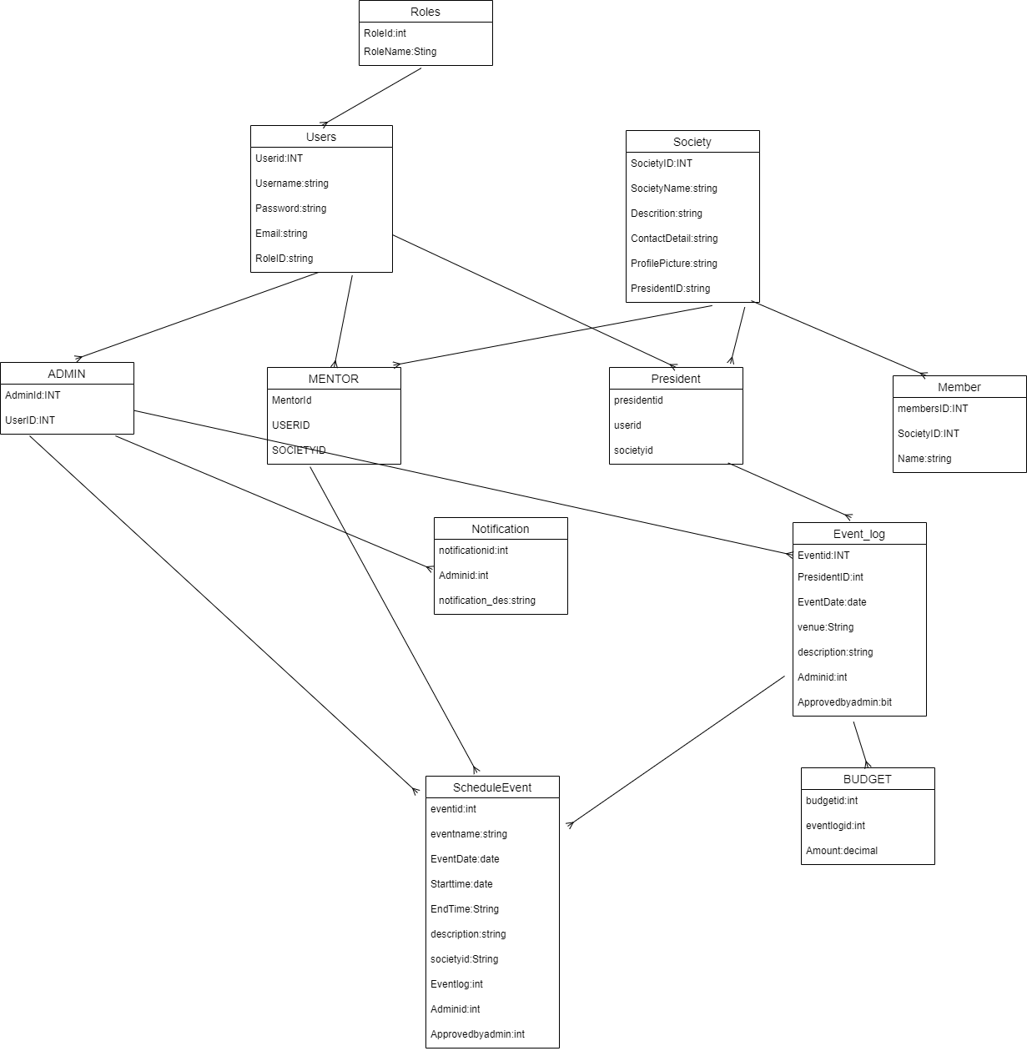

**USECASE DIAGRAM**

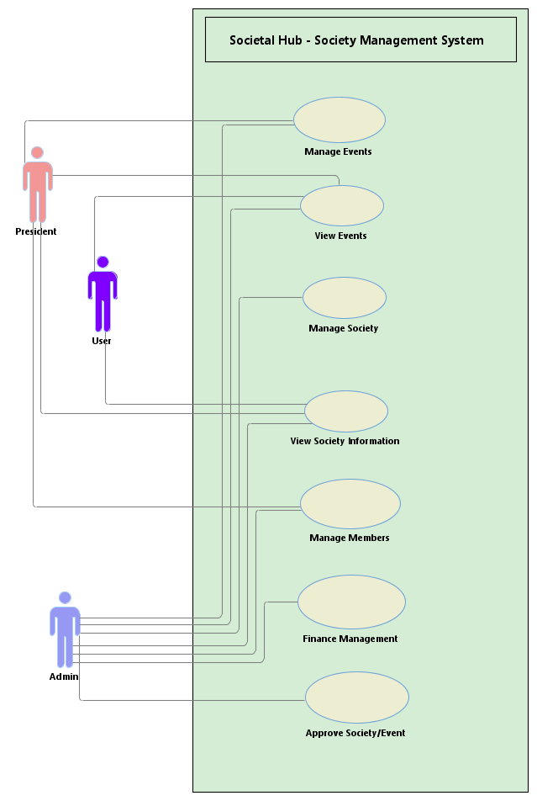

**SEQUENCE DIAGRAMS**

Register Event

View Society Info

Delete Event

1. **MODULES AND THEIR USER STORIES**

**2.1 Membership Management**

**User Story:**

1. 1. As a Student, I want my system to give me prompts if my request has been approved
2. As a Student, I want to see the list of registered socities
3. As an Admin, I want to see the schedule log for the socities

**2.2 Resource Sharing**

**User Story:**

* 1. As a student, I want to see the financial resources of every society
  2. As an admin, I want to be updated with the financial resources
  3. As a manager, I want to be able to upload the resource details from my system
  4. **2.3 Financial Management**

**User Story:**

* + - * 1. As a Manager I want to view and manage the finances of my society.
        2. As a Student, I want to view the finances used by other societies.
        3. As an admin, I want to be updated on society finances.
        4. As an admin, I want to approve a society’s finances.

1. **SCRUM BOARD** 
   * 1. Scrum Board Creation for sprint 2 including backlogs and Overview of the previous sprint

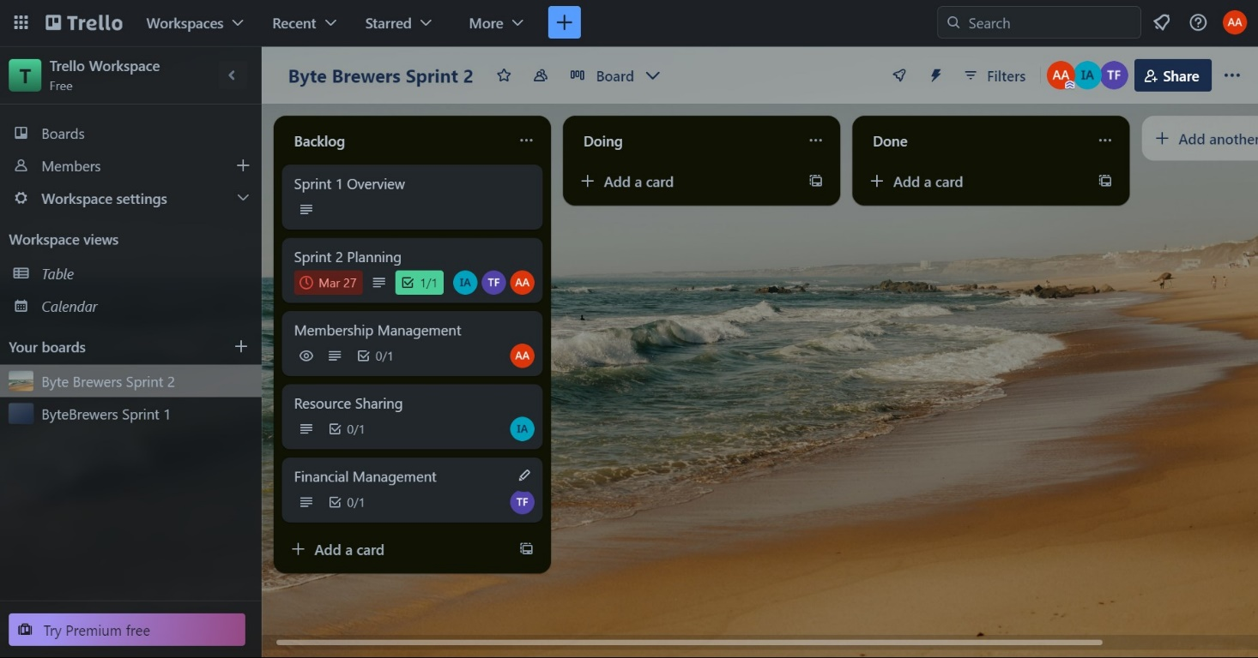

* + 1. 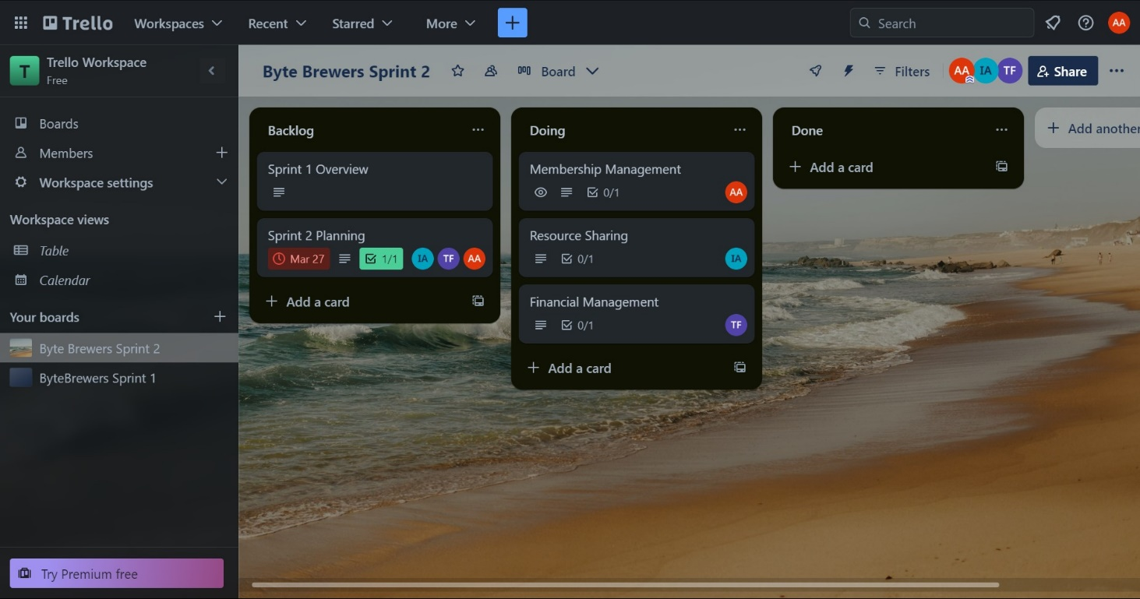Scrum Board while mid work. Membership management module was built first and then resource and financial sharing.
    2. 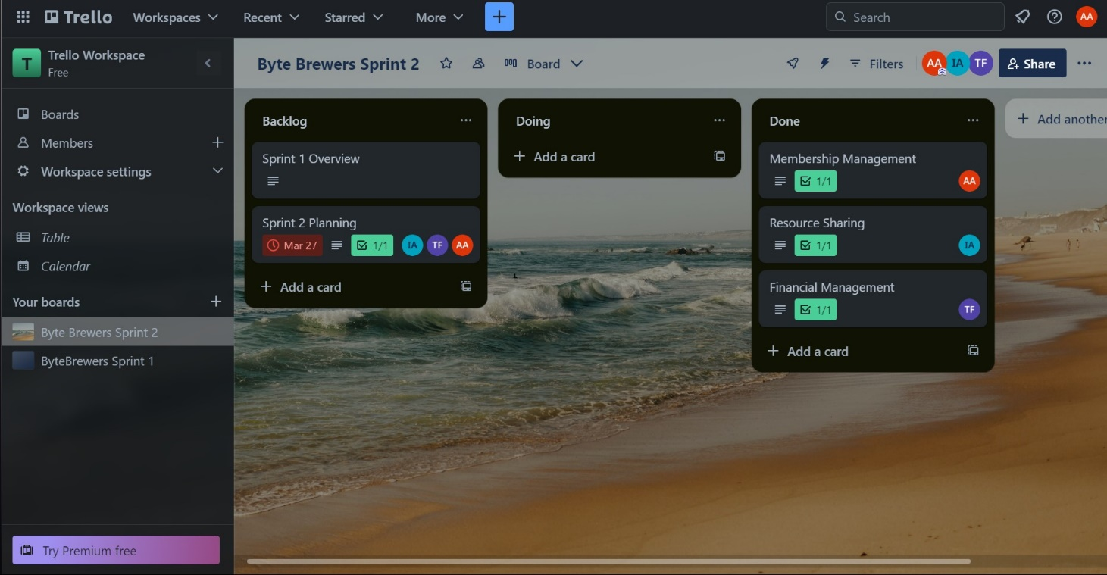Final Scrum Board, all the modules were completed and no work had to be pushed in to the “LeftOvers”:

1. **WORK DIVISION:**

Following is the modular breakdown of work and the teammates involved with each module.

* + 1. Membership Management done by Affan Anwar
    2. Resource Sharing done by Aaimlik Abbasi
    3. Financial Management done by Taha Farooq
    4. Documentation done by all the team members combined

**RESOURCE SHARING**

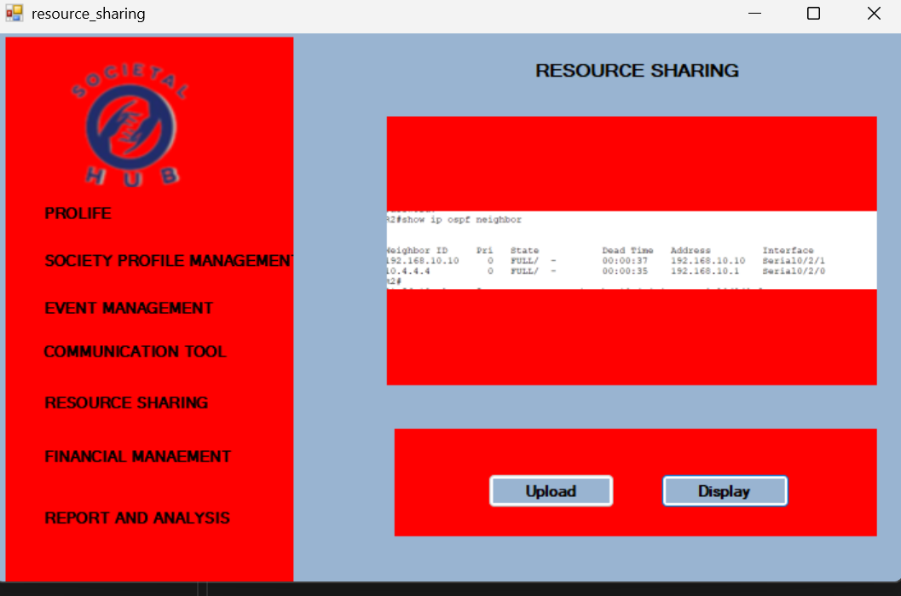

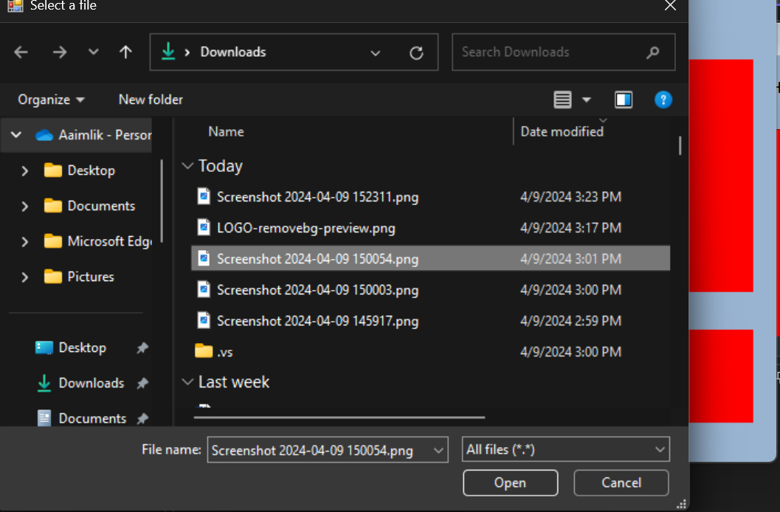

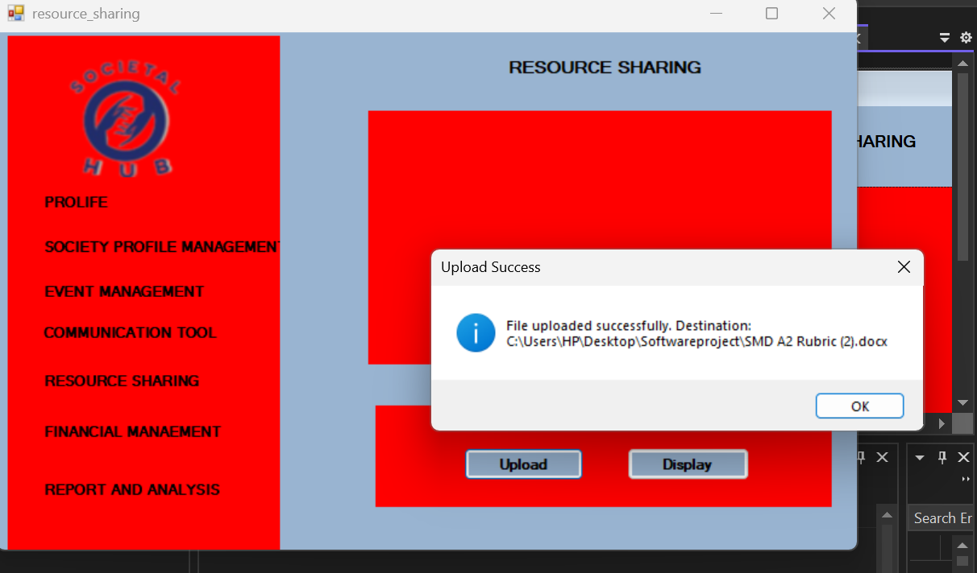

**FINANCIAL MANAGEMENT**

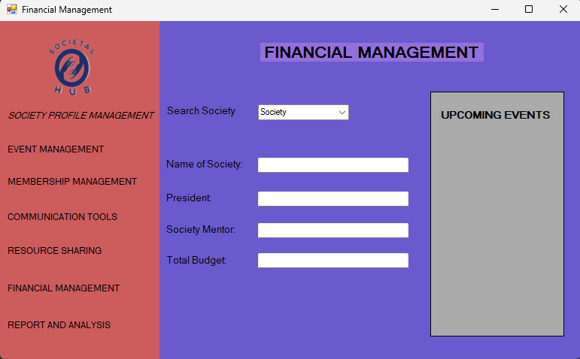

**MEMBERSHIP MANAGEMENT**



